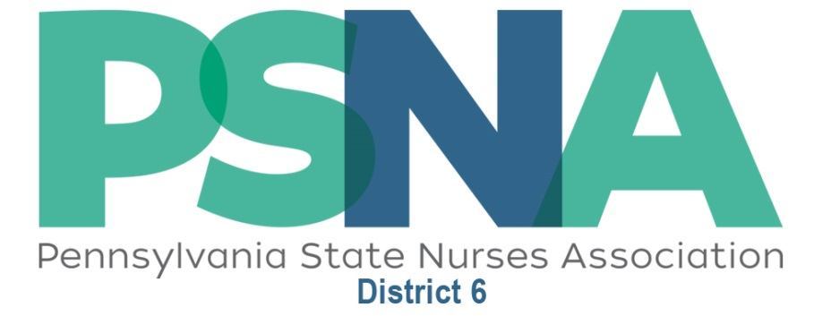
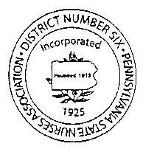

Advocacy, Information and Education for the Registered Nurses of
Allegheny, Armstrong, Beaver, Butler, Fayette, Greene, Lawrence,
Washington, Westmoreland Counties

Health Literacy in Healthcare

Tuesday, April 4, 2017
Life’s Work
1323 Forbes Ave., Pittsburgh, PA 15219

Agenda

5:30 – 5:50 PM / General Meeting (with light meal)
6:00 – 7:00 PM / Program

Speakers

Dina M. Sheriff, MSN, RN-BC, CCRN-K
Adjunct Faculty, Community College of Allegheny County

About the Event
- Accurately verbalize the definition of health literacy
- Compare and contrast low general literacy and low health literacy
- List the most common traits of low health literacy
- List potential negative outcomes of low health literacy

This activity has been submitted to Pennsylvania State Nurses Association for approval to award contact hours. Pennsylvania State Nurses Association is accredited as an approver of continuing nursing education by the American Nurses Credentialing Center’s Commission on Accreditation.

Join Us! ALL RNs, nursing students and guests are invited to attend.

Registration is required

EVENT: Health Literacy in Healthcare
Tuesday, April 4, 2017
5:30 – 7:00 PM
Life’s Work, Pittsburgh

Registration deadline is April 1, 2017

Name:

Credentials:

Email:

Phone:

Address:

City / State / Zip:

Guest Name:

_____ Number attending $10 per person

Total amount enclosed $ __________

NOTE: You can pre-register for this event and pay at the door. Let us know you’re coming:

https://formsmarts.com/form/1udw

Questions? Contact Aparna Gupta at rnaparna04@yahoo.com.

Please note that there are no refunds for program registration.

Checks payable to: District 06 PA State Nurses Association.
Send to: Tamara J. Waner, Treasurer, PSNA District 06
PO Box 121, East Vandergrift, PA 15629

