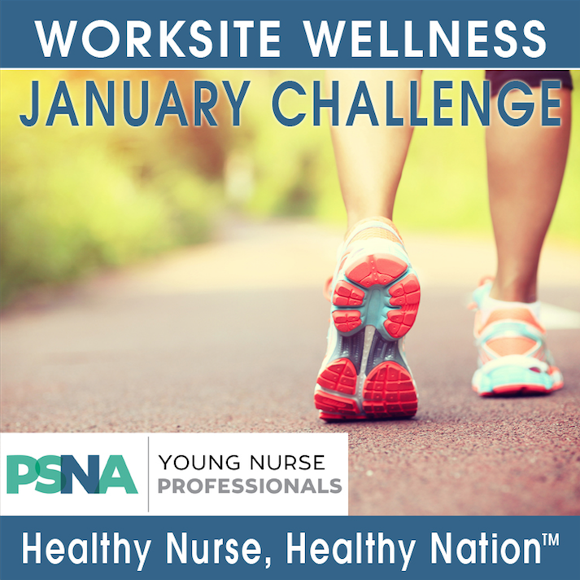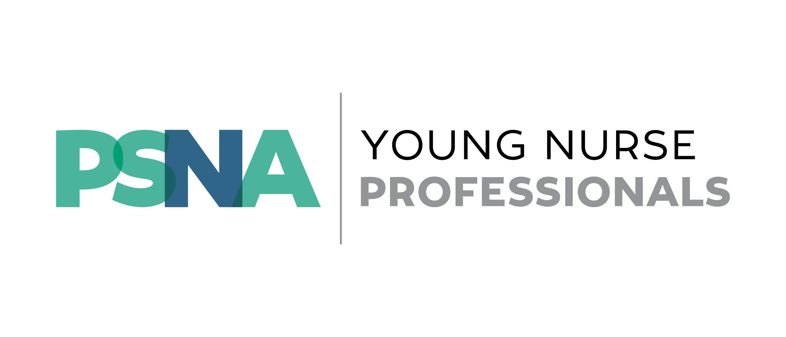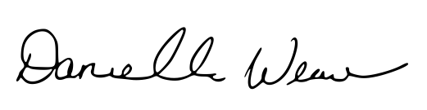 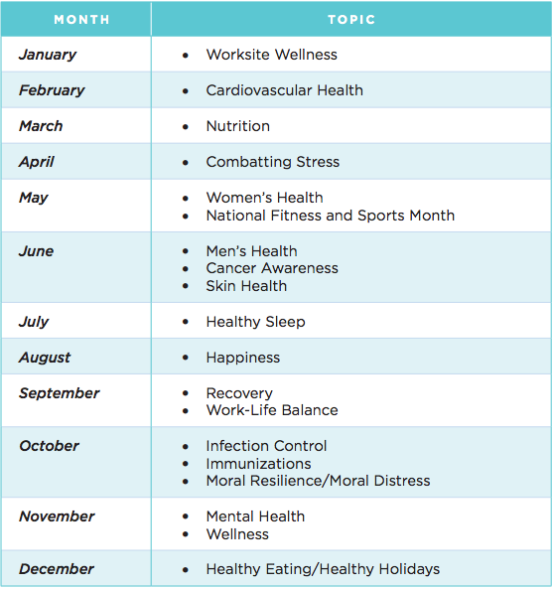

Letter from the Editor

Year of the Healthy Nurse

YNP Member Experience

Healthy Nurse, Healthy Nation

**Join the YNPs in the Healthy Nurse,**

**Healthy Nation Grand Challenge!**

The ANA has deemed 2017 ***The Year of the Healthy Nurse***, and the YNPs have partnered to take part in their **Healthy Nurse, Healthy Nation Grand Challenge**!

Every month, the YNPs will host in-person events and virtual opportunities to engage with the ANA monthly health topic. First up for January is Worksite Wellness, and we’ve already begun our January Step Challenge!

Did you know that nurses typically walk 5 miles in one shift? Now get rewarded for it! Through the month of January, track your steps- at work, at home, at the gym, at the grocery store- anywhere you get moving! At the end of the month, PSNA will tally your total steps. The top two members with the most steps will win brand new Fitbits to keep their healthy lifestyle going! Sign up by clicking on the link [here](https://www.ChallengeRunner.com/login/challenge/3125/13912/8c8ccf9545)!

We have some great things planned, so be sure to stay tuned for information about upcoming events! Let’s make 2017 our healthiest year ever, YNPs!

**The Year of the Healthy Nurse**

[Follow](https://www.instagram.com/panurses/) us!

Like our [page](https://www.facebook.com/PAStateNursesAssociation/?fref=ts)!

**Letter from the Editor**

Happy 2017, YNPs!

Every year, I eat too much and exercise too little during the holidays. And while I always have the best intentions to be healthier in the new year, I seem to fall short when I take on that challenge alone.

That’s why this year is special—the ANA has deemed this year *The Year of the Healthy Nurse*, so now I have support as I try to make 2017 my healthiest year yet!

I hope you’ll join the YNPs as we take part in the Healthy Nurse, Healthy Nation Grand Challenge. We have some great events planned for the rest of the year to coincide with the ANA health topics. This month’s step challenge has already been great—and it’s forced me to get up and get moving!

I look forward to hopefully meeting you this year and hearing about how healthy you have been in 2017!

Danielle Weaver, BSN, RN

YNP Pittsburgh

**In this issue:**

Tweet at us! @panurses

Nursing is a life-long learning profession. We must be prepared to continue to learn as the healthcare environment is ever changing. Learning encompasses not only best practices and evidence-based medicine, but also learning how to advocate for our patients, our profession, and healthcare in general. Advocating for the profession can occur in many settings.

**YNP Member Experience**

This past October, we had the opportunity to meet nurses from around the country in Washington D.C. at the American Nurse Advocacy Institute (ANAI). We attended various sessions that provided a great insight into how politics affects both policy making and the nursing profession. Some of the sessions included learning about how to communicate effectively with legislators and their staff, learning about digital advocacy, and conducting a political environmental scan. We were engaged in understanding how legislators and their staff process healthcare information and why it is important for nursing to have a voice on healthcare topics.

We hope to use our ANAI experience to help PSNA support both nurses and nursing legislation initiatives in Pennsylvania. Our focus will be on the larger topic of the opioid crisis and epidemic in Pennsylvania. We are taking an approach to look at the impact of drug use and addiction on children and families in Pennsylvania. We look forward to working with PSNA staff to further define our project and understand Pennsylvania’s political scene.

**Caroline Toomey, BSN, RN**

**Ashley Homer, BSN, RN**

**YNP Philadelphia**

During our visits on Capitol Hill, we had the opportunity to advocate for the nursing profession. Two specific topics that impact nursing are Title VII Nursing Workforce Reauthorization Act, which provides funding for nursing education, and the Home Health Care Planning Improvement Act, which supports utilizing Advanced Practice Nurses in veteran’s healthcare to provide better access to providers. Both topics have bills introduced in Congress and have some support, but they are not yet laws. We met with a staffer from a representative from Florida and staffers from a senator from Louisiana to provide critical support of these bills. While we did not have the opportunity to meet with Pennsylvania lawmakers or their staffers, we did stop by their offices and were warmly greeted by their office staff. We learned valuable lessons in how to best prepare for meetings on Capitol Hill.

**Tales from the**

**American Nurse Advocacy Institute (ANAI)**



**Healthy Nurse, Healthy Nation Grand Challenge**

Do you want to eat healthier, be more active, get better sleep, and have more joy? This is your year! ANA is declaring 2017 to be the Year of the Healthy Nurse! Join us as every month we tackle specific wellness issues that all of us can improve.

ANA defines a healthy nurse as someone who actively focuses on creating and maintaining a balance and synergy of physical, intellectual, emotional, social, spiritual, personal and professional wellbeing. We feel that nurses are ideally positioned to be the best role models, educators, and advocates of health, safety, and wellness. This year, let's improve the health of the nation's 3.6 million registered nurses and in turn improve the health of the nation!

The YNPs will host in-person events throughout Pennsylvania so we can practice being healthy together. But even if you can’t make it to our events, we will have opportunities for you to share your engagement with us on social media! Be sure to connect with us on [Facebook](https://www.facebook.com/PSNAYNP/) for the most up-to-date information!

