Some recently asked questions:

- How do I reset my NARS password?
HOW TO RESET YOUR PASSWORD IN NARS

Forgot your password? Please visit the NARS login screen and click on request a password.

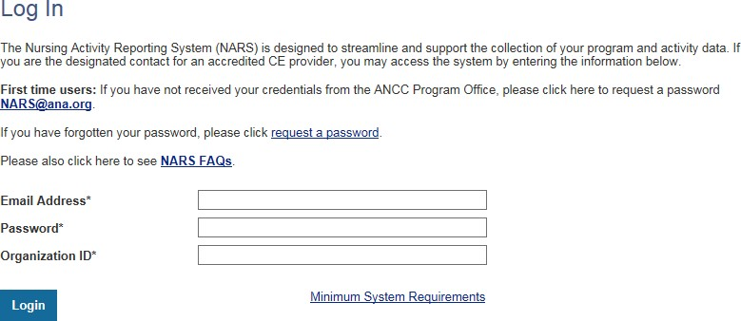

Enter your email address or the user’s email address that you are trying to request a password for. Then enter your Organization ID or the user’s organization ID that you are trying to request a password for.
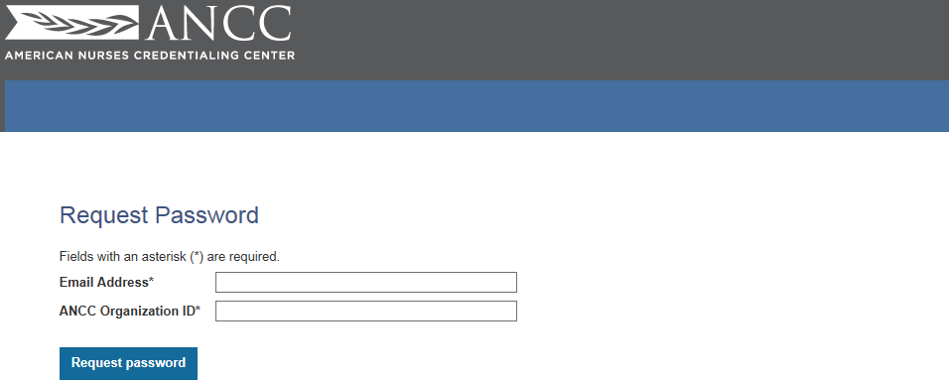

- Do I need to submit the annual report via NARS on 2/2/2021 AND again when I re-apply?
*No, NARS data is entered once a year and attested. When you submit your self-study for renewal, you can add your report for the previous year (generated in NARS). If you have questions as to how to do that let me know.

- Are we still able to make our own APU Planning form for our activities?
*Yes – as long as for your planning form has all of the required items by ANCC

- Do you need to provide an agenda for activities greater than 2 or 3 hours?
It is more than 2 – there must be a typo in the new manual. My apologies.

- How long am I able to view a zoom that I missed when you send them out?
14 days – Try to take a look at those as soon as possible. Once the website is up and running again…. (soon I HOPE) – I’ll be adding them to the website. For now I have to use “we-transfer” to get them to you and there is a time limit on that
- My APU structure is changing, do I need to let you know now or when I re-apply? What’s expected of me?

See page 24 of the manual, copied below:

Section III: Approved Provider Responsibilities

Approved Provider Responsibilities:

The APUs are responsible to:

- Maintain adherence to all applicable federal, state, and local laws and regulations that affect the APU’s ability to meet ANCC criteria.
- Identify a PNP who has overall responsibility for the APU’s adherence to ANCC accreditation criteria, including orientation of other NPs and key personnel.
- Ensure that a qualified NP is an active participant in the assessment, planning, implementation, and evaluation of each educational activity.
- Ensure that each learning activity planning committee have a minimum of a qualified NP and one other person to plan each activity; the NP to ensure adherence to criteria and at least one person with subject matter expertise related to the activity.
- Ensure that the NP is responsible and accountable to review and evaluate actual or potential COI for each planning committee member, faculty, presenter, author, content reviewer and anyone else who has influence or control over the content of the learning activity.
- Notify the Pennsylvania State Nurses Association in writing within seven business days of the discovery or occurrence of the following:
  - Significant changes or events that impair the ability to meet ANCC/Pennsylvania State Nurses Association NCPD requirements or affect eligibility to remain an Approved Provider, including change in commercial interest status.
  - Any event that might result in adverse media coverage related to the delivery of NCPD activities.
- Notify the Pennsylvania State Nurses Association within 30 days of any changes within the organization, including demographics (name, address, business Website), a decision to not re-apply as a PU, change in PNP, or a change in ownership of the organization.

Recordkeeping

All records must be maintained and retrievable for six years. Activity files must have the following components:

- Title and location of activity
- Type of activity format: Live or Enduring
- Date live activity presented, or for ongoing enduring activities, date first offered and subsequent review dates
- Description of professional practice gap
- Evidence that validates professional practice gap
- Educational need that underlies the professional practice gap
- Description of target audience
- Desired learning outcomes
- Description of evidence-based content with supporting reference or resources
- Learner engagement strategies used
- Criteria for awarding of contact hour
- Description of evaluation method (evidence that change in knowledge, skills, and/or practices of target audiences was assessed)
- Names and credentials of all individuals in a position to control content (planners, presenters, faculty, authors, and/or content reviewers) and must identify who fills the various roles
- Demonstration of COI process for all individuals in a position to control content (planners, presenters, faculty, authors, and/or content reviewers)
- Name of individual
- Past 12 months
- Spouse/significant other
- Individual providing the information is provided a definition of a CIO
- Evidence of a resolution of process, if applicable
- Number of contact hours awarded for activity and method of calculation (Provider must keep a record of the number of contact hours earned by each participant. If the activity is longer than three hours, agenda was provided for the entire activity.)
- Documentation of completion and/or certificate must include:
  - Title and date of the educational activity
  - Name and address of provider of the educational activity (Web address acceptable)
  - Number of contact hours awarded
  - Approved Provider statement
  - Participant name
- Commercial Support Agreement with signature and date (if applicable)
- Name of the CIO
- Name of the Provider
- Complete description of all the CS provided, including both financial and in-kind support
- Statement that the CIO will not participate in planning, developing, implementing, or evaluating the educational activity
- Statement that the CIO will not recruit learners from the education activity for any purpose
- Description of how the CS must be used by the Provider (unrestricted use and/or restricted use)
- Signature of a duly authorized representative of the CIO with the authority to enter the binding contracts on behalf of the CIO
- Signature of a duly authorized representative of the Provider with the authority to enter the binding contracts on behalf of the Provider
- Date on which the written agreement was signed
- Evidence of required information provided to the learners (Disclosures):
  - Approved Provider statement of provider awarding contact hours
  - Criteria for awarding contact hours
  - Presence or absence of conflicts of interest for all individuals in a position to control content (planning committee, presenters, faculty, authors, and/or content reviewers)
  - Commercial support (if applicable)
  - Expiration date (enduring material only)
  - Joint Providership (if applicable)
- Materials associated with this activity (marketing materials, advertising agendas, and certificates of completion) must clearly indicate the Provider awarding contact hours and responsible for adherence to the ANCC criteria
- Summative evaluation

- Do I need to notify you every time a NP changes/leaves etc.? N
No – only the PNP (see above). Your NP changes can be explained when you re-apply.
- Can an Approved Provider Unit actually “review” and approve education?
No – you can plan, implement and evaluate only. This seems to be misunderstood by some. If anyone has more questions about this please come to our next office hours and we can discuss it more

Happy Thanksgiving!
Kelly

